**LAB 5**

**LAB 5.1: UNDERSTANDING, CREATING AND SIMULATING MULTIPLE VLANS IN A SINGLE SWITCH.**

**OBJECTIVE:** To understand and create multiple VLANS in a switch

**BACKGROUND:** VLAN is a custom network which is created from one or more local area networks in order to limit access to a specified group of users by dividing workstations into different isolated VLAN.

**TOPOLOGY**

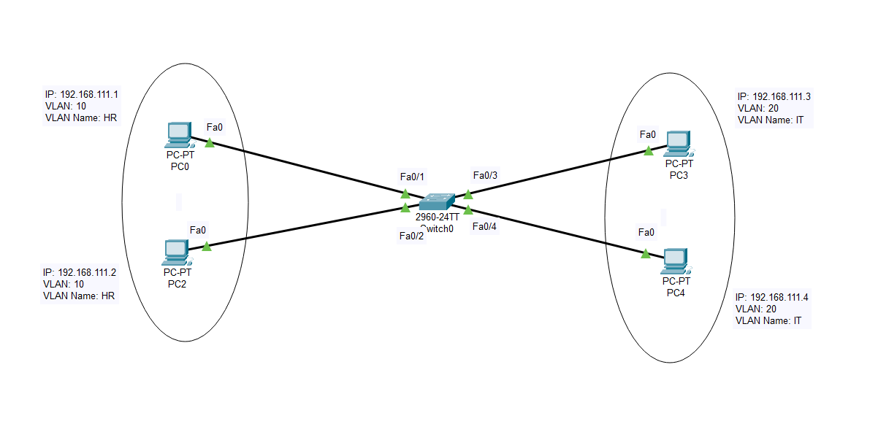

**IP ADDRESSING PLAN**

|  |  |  |  |  |  |
| --- | --- | --- | --- | --- | --- |
| Device | Interface | IP address | Subnetmask | VLAN | Default gateway |
| PC0 | NIC | 192.168.101.1 | 255.255.255.0 | 10/HR | - |
| PC1 | NIC | 192.168.101.2 | 255.255.255.0 | 10/HR | - |
| PC2 | NIC | 192.168.101.3 | 255.255.255.0 | 20/IT | - |
| PC3 | NIC | 192.168.101.4 | 255.255.255.0 | 20/IT | - |

**PROCEDURE**

1. Create the topology as shown above
2. Assign the IP address to each PC as shown in IP addressing plan
3. Create two VLANs in a switch as

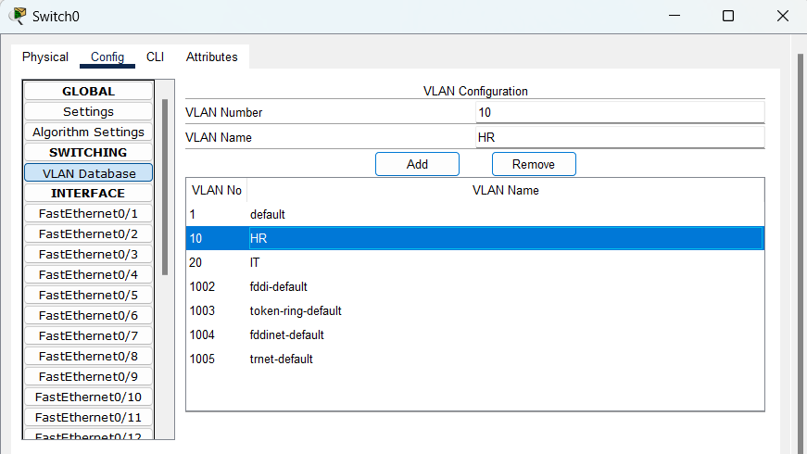

4. Assign the PC connected interface of switch into the VLAN you want to assign

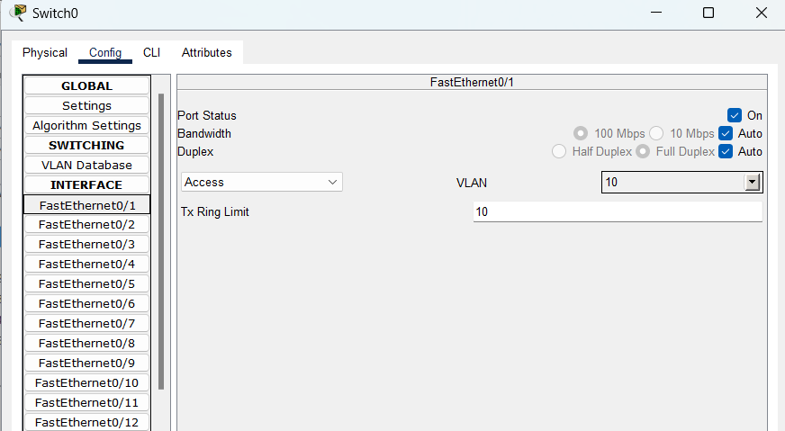

**VERIFICATION**

1. Ping the PC as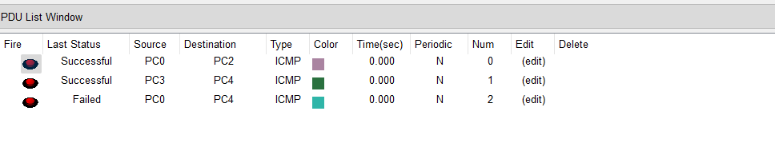

PC with in a VLAN gets communicated but PC present in different VLAN can not communicate.

1. View the details of VLANs created in switch as

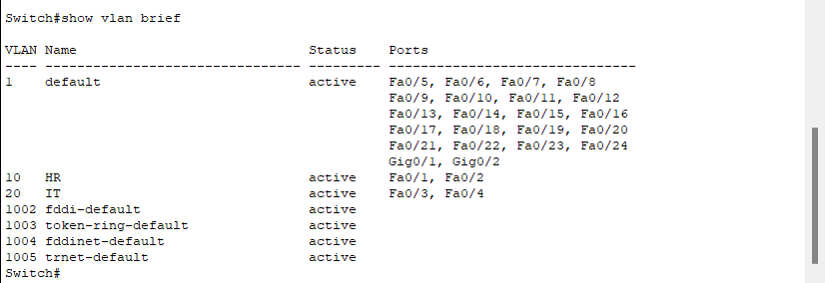

**CONCLUSION**

In this way we can create multiple VLANs within a LAN (in a Switch) so that broadcast domain can be divided and gets minimized in a LAN.

**LAB 5.2: UNDERSTANDING, CREATING, AND SIMULATING MULTIPLE VLANS DISTRIBUTED IN MULTIPLE SWITCH**

**OBJECTIVE:** TO understand and create multiple VLANS distributed in multiple switch and routing among them

**TOOLS USED:** Packet Tracer

**BACKGROUND:** Virtual Local Area Networks or Virtual LANs (VLANs) are a logical group of computers that appear to be on the same LAN irrespective of the configuration of the underlying physical network. Native VLAN is simply the one VLAN which traverses a Trunk port without a VLAN tag. An Access switch port carries traffic for only one VLAN whereas Trunk port carries traffic for multiple VLANs. When frames traverse a Trunk port, a VLAN tag is added to distinguish which frames belong to which VLANs. Access ports do not require a VLAN tag, since all incoming and outgoing frames belong to a single VLAN.

**TOPOLOGY**

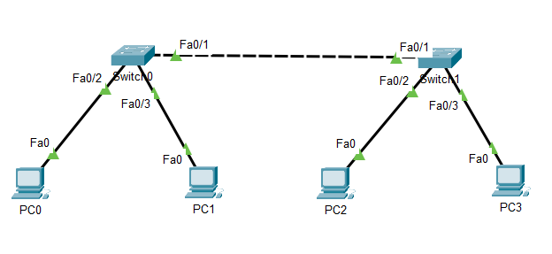

**IP ADDRESSING PLAN**

|  |  |  |  |  |  |
| --- | --- | --- | --- | --- | --- |
| Device | Interface | IP address | Subnet Mask | VLAN | Default gateway |
| PC0 | NIC | 192.168.11.1 | 255.255.255.0 | 10/HR | - |
| PC1 | NIC | 192.168.11.2 | 255.255.255.0 | 20/IT | - |
| PC2 | NIC | 192.168.11.3 | 255.255.255.0 | 20/IT | - |
| PC3 | NIC | 192.168.11.4 | 255.255.255.0 | 10/HR | - |

**PROCEDURE**

1. Create the topology as shown above
2. Assign the IP address to each PC as shown in IP addressing plan
3. Create two VLANs in each switch as

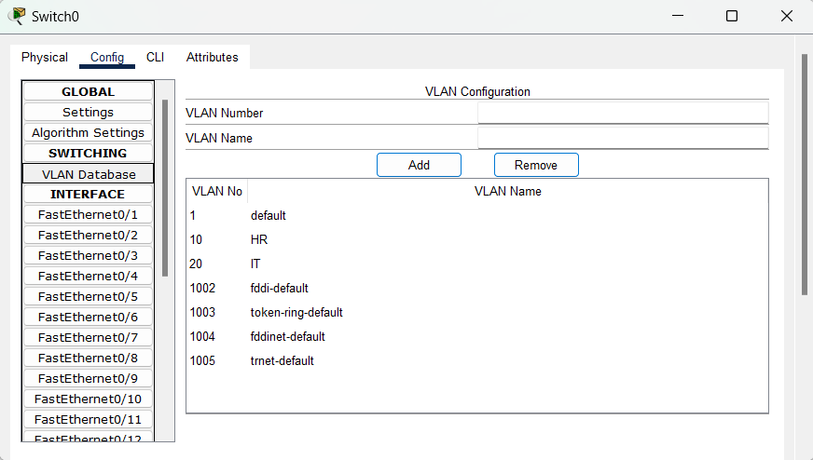

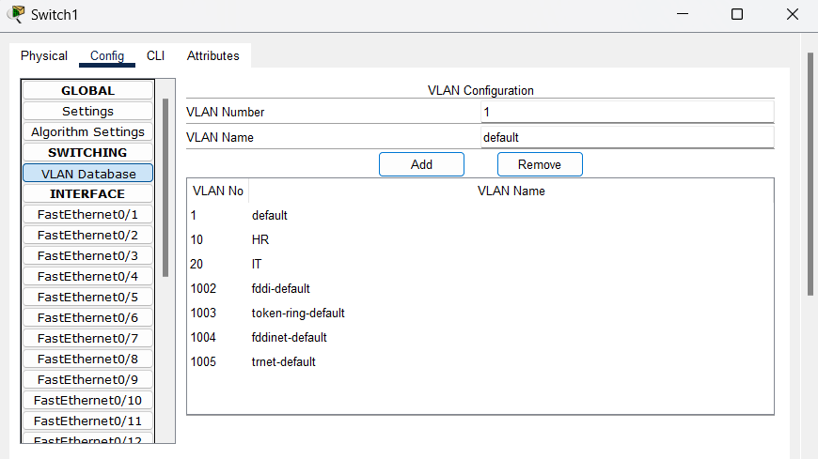

1. Assign the PC connected interface of switch into the VLAN you want to assign

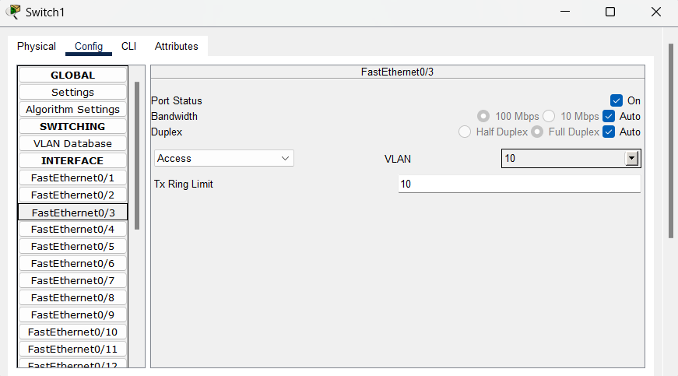

Similarly, for other interfaces in switch 0 and go to into switch1 and assign interface to each VLAN as shown above. During assignment fa 0/1 interface in each switch must make trunk other should be access.

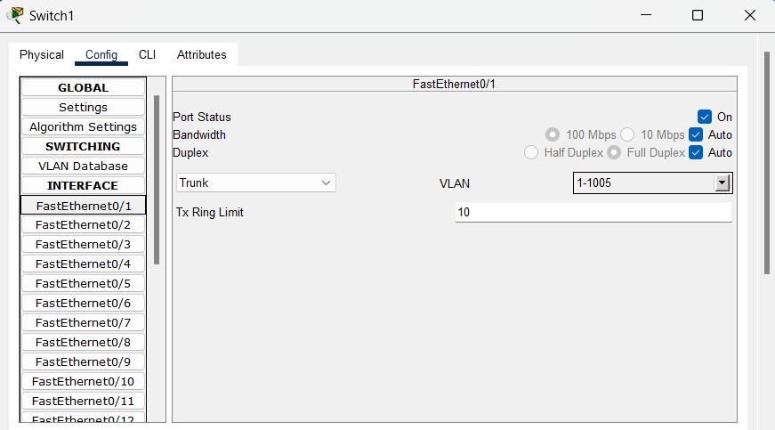

**VERIFICATION**

Ping the PC as

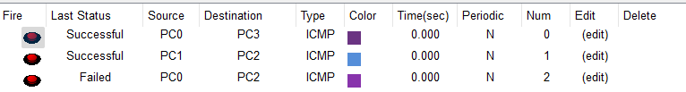

PC present in Same VLAN gets communicated irrespective of their location and connection switch however, PC present in different VLAN cannot communicate.

View the details of VLANs created in switch as

In switch 0,

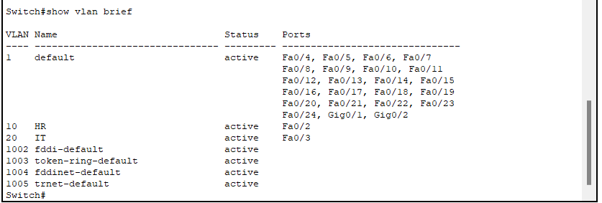

In switch 1,

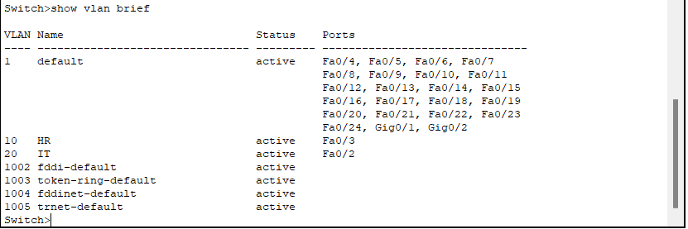

**CONCLUSION**

In this way we can create multiple VLANs distributed in multiple switches so that broadcast domain can be distributed in multiple locations.

**LAB 5.3: UNDERSTANDING, CREATING AND SIMULATING MULTIPLE VLANS DISTRIBUTED IN MULTIPLE SWITCH ANF ROUTING AMONG VLANS**

**OBJECTIVE:** To understand and create multiple VLANS distributed in multiple switch and routing among them

**TOOLS USED:** PACKET TRACER

**BACKGROUND**: Virtual LANs (VLANS) are networks segments on a switched LAN. Inter-VLAN routing refers to the movement of packets across the network between hosts in different network segments. VLANs make it easier for one to segment a network, which improves the performance of the network and makes it more flexible, since they are logical connections. VLANs act as separate subnet on the network. To move packets from one VLAN to another and enable communications among hosts, the VLAN network should be configured.

**TOPOLOGY**

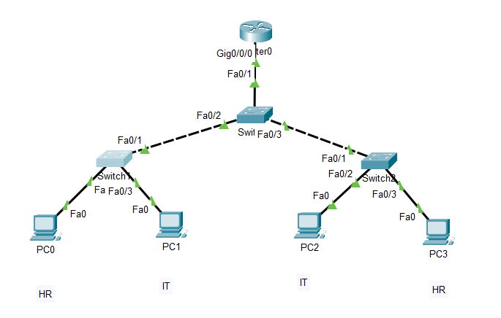

**IP ADDRESSING PLAN**

|  |  |  |  |  |  |
| --- | --- | --- | --- | --- | --- |
| Device | Interface | IP address | Subnet Mask | VLAN | Default gateway |
| PC0 | NIC | 192.168.10.2 | 255.255.255.0 | 10/HR | 192.168.10.1 |
| PC1 | NIC | 192.168.10.2 | 255.255.255.0 | 20/IT | 192.168.20.1 |
| PC2 | NIC | 192.168.20.3 | 255.255.255.0 | 20/IT | 192.168.20.1 |
| PC3 | NIC | 192.168.20.3 | 255.255.255.0 | 10/HR | 192.168.10.1 |
| Router | GigabitEthernet  0/0/0.10 | 192.168.10.1 | 255.255.255.0 | - | - |
| Router | GigabitEthernet  0/0/0.20 | 192.168.20.1 | 255.255.255.0 |  |  |

**PROCEDURE**

1. Create the topology as shown above
2. Assign the IP address to each PC as shown in IP addressing plan
3. Create two VLANs in each switch as



Do the same for switch 1 and switch 2 also.

And run the following additional command in switch 0 and switch 1

Switch>enable

Switch#config terminal

Switch(config)#vtp mode client

1. Perform the following configurations in router

Router>enable

Router#configure terminal

Router(config-if)#interface GigabitEthernet0/0/0.10

Router (config-subif)#encapsulation dot1Q 10

Router(config-subif)#ip address 192.168.10.1 255.255.255.0

Router(config-subif)#exit

Router(config)#interface GigabitEthernet 0/0/0.20

Router(config-subif)#encapsulation dot1Q 20

Router(config-subif)#ip address 192.168.20.1 255.255.255.0

Router(config-subif)#exit

1. Assign the PC connected interface of switch into the VLAN you want to assign

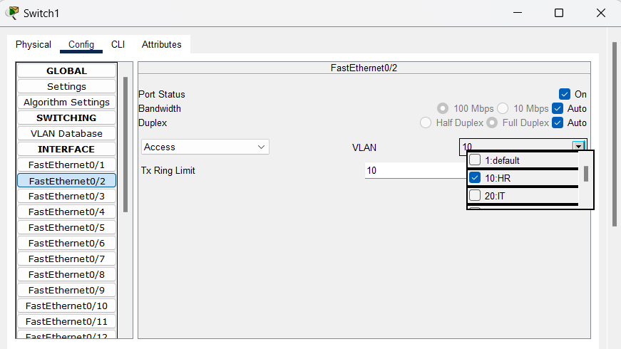

Similarly, for other interfaces in switch 0 and go to into switch1 and assign interface to each VLAN as shown above. During assignment fa 0/1 interface in switch 1 and switch 2 must make trunk other should be access. Similarly, all the interfaces 1 to 3 in switch 0 must be trunk.

**VERIFICATION**

* Ping the PC as

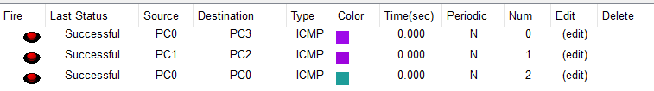

* View the details of VLANs created in switch as

In switch 0,

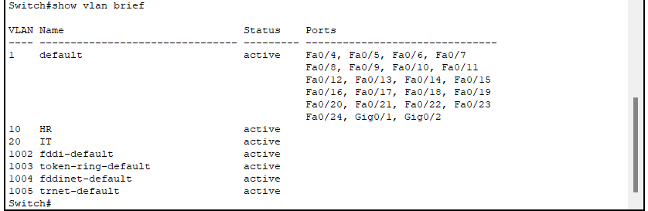

In switch 1,

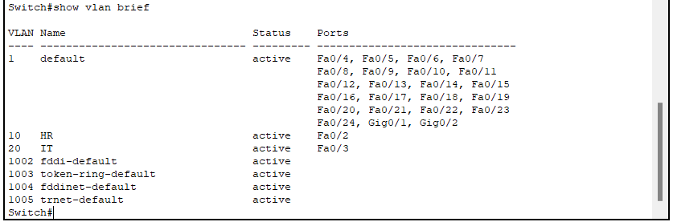

In switch 2,

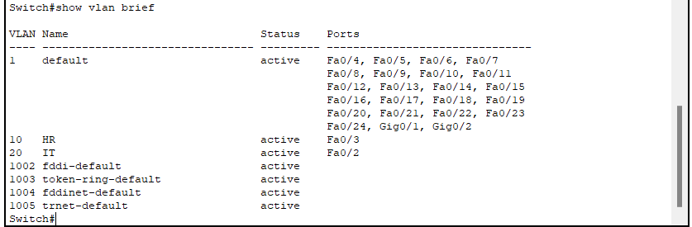

**CONCLUSION**

In this way we can create multiple VLANs distributed in multiple switches and also perform the inter-VLAN routing in order to make communication possible among VLANs